Chapter 22
Real Options
22-1. Your company is planning on opening an office in Japan. Profits depend on how fast the economy in Japan recovers from its current recession. There is a 50% chance of recovery this year. You are trying to decide whether to open the office now or in a year. Construct the decision tree that shows the choices you have to open the office either today or one year from now.
Decision Tree
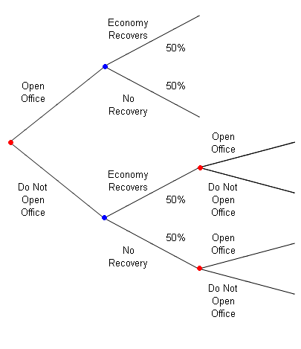

22-2. You are trying to decide whether to make an investment of $500 million in a new technology to produce Everlasting Gobstoppers. There is a 60% chance that the market for these candies will produce profits of $100 million annually, a 20% chance the market will produce profits of $50 million, and a 20% chance that there will be no profits. The size of the market will become clear one year from now. Currently, the cost of capital of the project is 11% per year. There is a 20% chance that the cost of capital will drop to 9% in a year and stay at that level forever, and an 80% chance that it will stay at 11% forever. Movements in the cost of capital are unrelated to the size of the candy market. Construct the decision tree that shows the choices you have to make the investment either today or one year from now.
Decision Tree
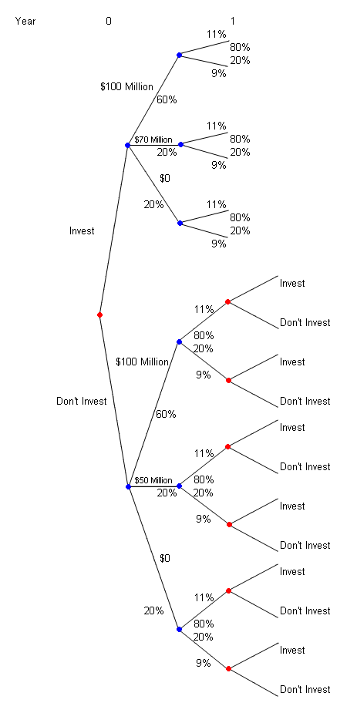
22-3. Using the information in Problem 2, rework the problem assuming you find out the size of the Everlasting Gobstopper market one year after you make the investment. That is, if you do not make the investment, you do not find out the size of the market. Construct the decision tree that shows the choices you have under these circumstances.
Decision Tree
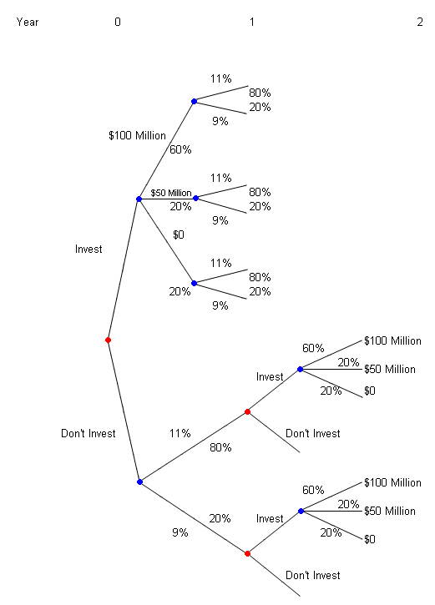
Year 0 1 2
22-4. Describe the benefits and costs of delaying an investment opportunity.
By delaying, you delay the benefits of taking on the project and your competitors might take advantage of this delay. However, by delaying, uncertainty can be resolved, so you can become better informed and make better decisions.
22-5. You are a financial analyst at Global Conglomerate and are considering entering the shoe business. You believe that you have a very narrow window for entering this market. Because of Christmas demand, the time is right today and you believe that exactly a year from now would also be a good opportunity. Other than these two windows, you do not think another opportunity will exist to break into this business. It will cost you $35 million to enter the market. Because other shoe manufacturers exist and are public companies, you can construct a perfectly comparable company. Hence, you have decided to use the Black-Scholes formula to decide when and if you should enter the shoe business. Your analysis implies that the current value of an operating shoe company is $40 million and it has a beta of 1. However, the flow of customers is uncertain, so the value of the company is volatile—your analysis indicates that the volatility is 25% per year. Fifteen percent of the value of the company is attributable to the value of the free cash flows (cash available to you to spend how you wish) expected in the first year. If the one-year risk-free rate of interest is 4%:
a. Should Global enter this business and, if so, when?
b. How will the decision change if the current value of a shoe company is $36 million instead of $40 million?
c. Plot the value of your investment opportunity as a function of the current value of a shoe company.
d. Plot the beta of the investment opportunity as a function of the current value of a shoe company.
a. S^{x}= S – PV(Div) = 40(1 – 0.15) = 40(0.85)
PV(K) = 35 / (1.04) = 33.6538
T = 1
= 0.25
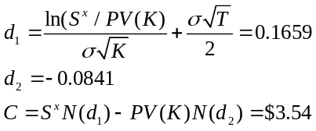
So the value of waiting is $3.54 million. The value of investing today is $40 – $35 = $5 million.
So they should enter the business now.
b. S^{x} = S – PV(Div) = 36(1. – 15) = 36(0.85)
PV(K) = 35 / (1.04) = 33.6538
T = 1
= 0.25
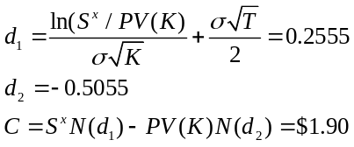
So the value of waiting is $1.90 million. The value of investing today is $36 – $35 = $1 million.
So they should not enter the business now.
c.
Decision Tree
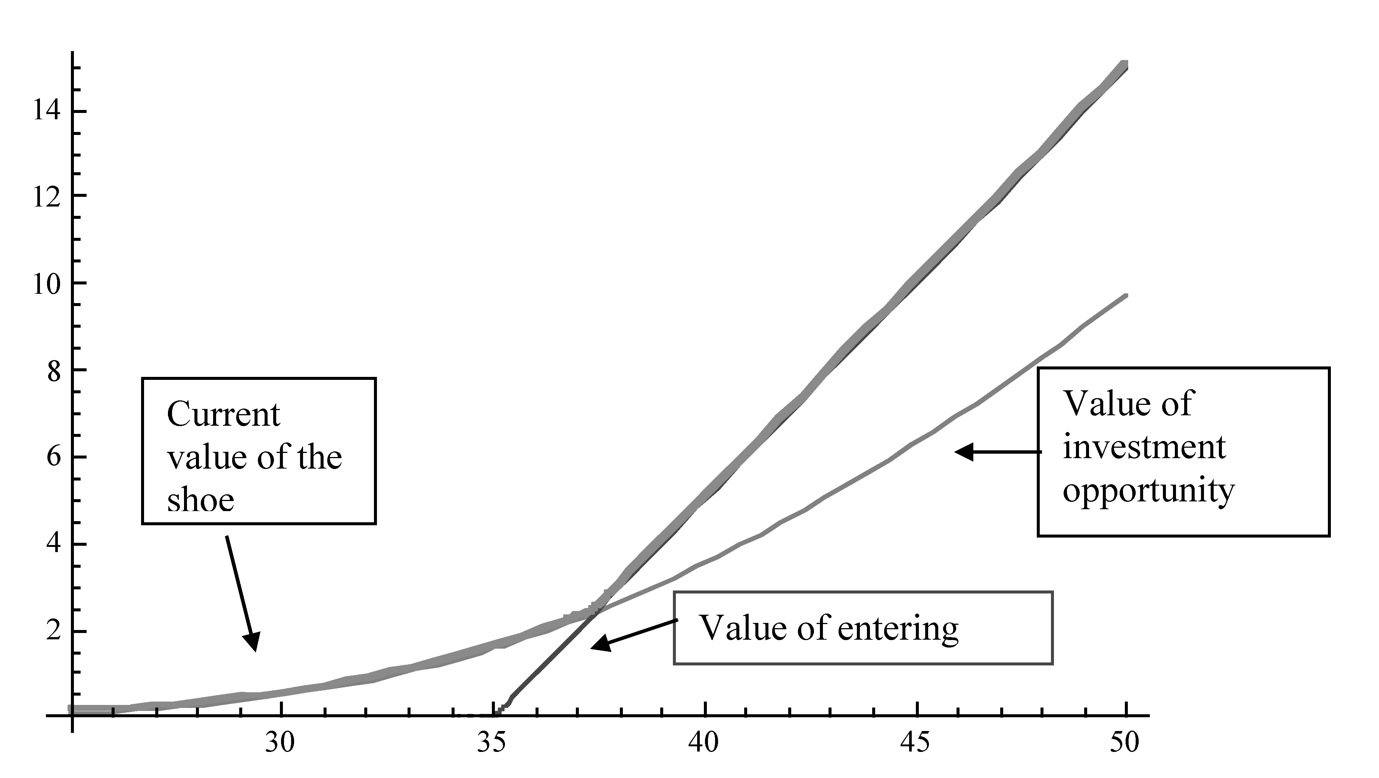

d. The beta of the investment opportunity is 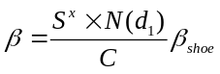when the shoe business is worth less then $37.4 million and is equal to 1 (the beta of a shoe business) when it is worth more:
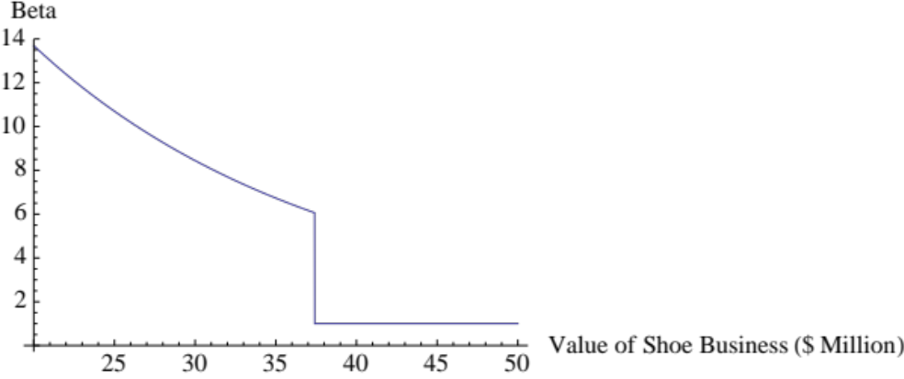
($ millions)
22-6. It is the beginning of September and you have been offered the following deal to go heli-skiing. If you pick the first week in January and pay for your vacation now, you can get a week of heli-skiing for $2500. However, if you cannot ski because the helicopters cannot fly due to bad weather, there is no snow, or you get sick, you do not get a refund. There is a 40% probability that you will not be able to ski. If you wait until the last minute and go only if you know that the conditions are perfect and you are healthy, the vacation will cost $4000. You estimate that the pleasure you get from heli-skiing is worth $6000 per week to you (if you had to pay any more than that, you would choose not to go). If your cost of capital is 8% per year, should you book ahead or wait?
Decision Tree
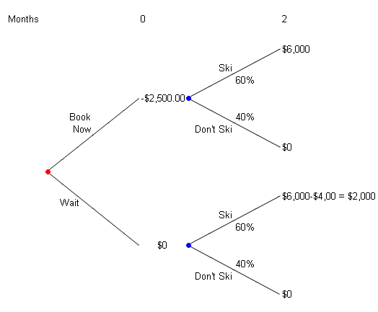
If you book now, your expected benefit from skiing in 4 months is:
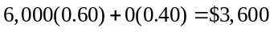
The NPV of booking today is therefore:
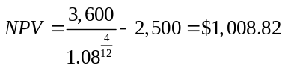
If you wait to book the expected benefit in 4 months is:
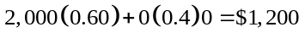
The PV of this today is
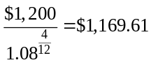
So you should wait.
22-7. A professor in the Computer Science department at United States Institute of Technology has just patented a new search engine technology and would like to sell it to you, an interested venture capitalist. The patent has a 17-year life. The technology will take a year to implement (there are no cash flows in the first year) and has an up-front cost of $100 million. You believe this technology will be able to capture 1% of the Internet search market, and currently this market generates profits of $1 billion per year. Over the next five years, the risk-neutral probability that profits will grow at 10% per year is 20% and the risk-neutral probability that profits will grow at 5% per year is 80%. This growth rate will become clear one year from now (after the first year of growth). After five years, profits are expected to decline 2% annually. No profits are expected after the patent runs out. Assume that all risk-free interest rates are constant (regardless of the term) at 10% per year.
a. Calculate the NPV of undertaking the investment today.
b. Calculate the NPV of waiting a year to make the investment decision.
c. What is your optimal investment strategy?
a. Decision Tree

 |  |  |  |  |  |  |  |  |  |  |  |  | 1 |  | 2 |  |  |  |  | 12
0 |  | 1 |  | 2 |  | 3 |  |  |  |  | 5 |  | 6 |  | 7 |  |  |  |  | 17
 |  | 20% |  | 10(1.1)² |  | 10(1.1)³ |  |  |  |  | 10(1.1)⁵ |  | 10(1.1)⁵ |  | 10(1.1)⁵ |  |  |  |  | 10(1.1)⁵
 |  |  |  |  |  |  |  |  |  |  |  | x (1 – 0.02) |  |  | x (1 – 0.02)² |  |  |  | x (1-0.02)¹²
–100 |  | 80% |  | 10(1.05)² |  | 10(1.05)³ |  |  |  |  | 10(1.05)⁵ |  | 10(1.05)⁵ |  | 10(1.05)⁵ |  |  |  |  | 10(1.05)⁵
 |  |  |  |  |  |  |  |  |  |  |  | x (1 – 0.02) |  |  | x (1 – 0.02)² |  |  |  | x (1 – 0.02)¹²

If the high growth rate state occurs, then the NPV is:
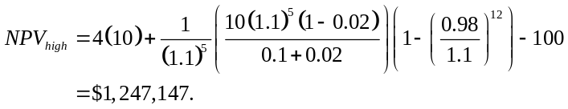
Note: Since the first four cash flows grow out of the same rate as the discount rate, their present value is just the sum of the cash flows.
If the low growth rate state occurs, then the NPV is:
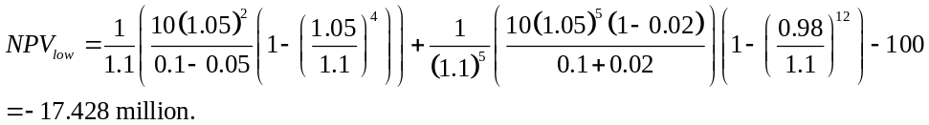
So the expected value is:
NPV = 1.25(0.20) + –17.428(0.80)
= –13.6927 million.
b. Decision Tree
If the high growth rate state occurs, then the NPV at time 1 is:
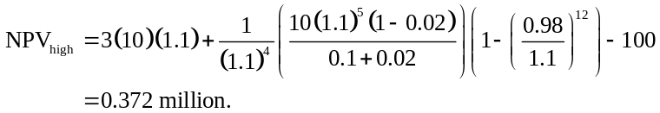
Note: Since the first three cash flows grow at the same rate as the discount rate, their present value is just the sum of the cash flows, so the value at time 1 is just the PV compounded.
If the low growth rate state occurs, then the NPV at time 1 is:
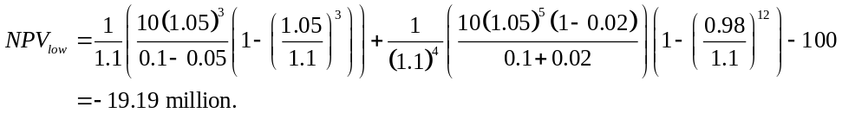
So investment will only occur in the high growth state. The value of this today is:
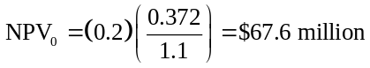
c. Since the NPV of investing today is negative, you should wait and only invest if the high state occurs.
22-8. Consider again the electric car dealership in Section 22.3. Suppose the current value of a dealership is $5 million because the first-year free cash flow is expected to be $500,000 rather than $600,000. What is the beta of a corporation whose only asset is a one-year option to open a dealership? What is the beta if the first year’s cash flows are expected to be $700,000, so a working dealership is worth $7 million?
First, you must compute the current value of the asset without the dividends that will be missed:
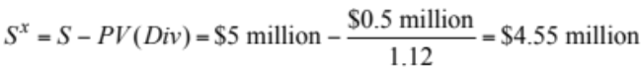
Next, using the information from Table 22.1 calculate the value of the call option to open the dealership:
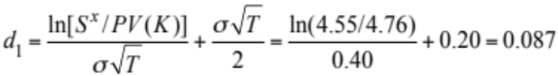
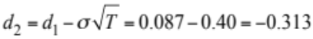
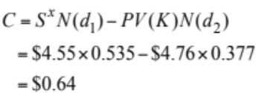
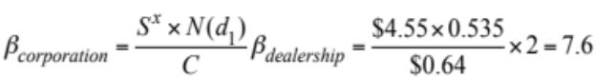
When the value of the firm is $7 million than it is optimal to invest immediately. We can see this by computing the value of the call similar to above: S^{x} = $6.38, d₁ = 0.932, d₂ = 0.532, C = $1.91. The value exercising immediately ($7 – $5 = $2 million) is greater than the value of the call ($1.91 million) so the beta of the corporation is equal to the beta of the dealership: 2.
22-9. Under the same assumptions as in Section 22.3, suppose your corporation owns an operating electric car dealership, together with one-year options to open five more.
a. What is the value and beta of your firm if the expected first-year free cash flow for all dealerships is $600,000?
b. What is the value and beta of your firm if the expected first-year free cash flow for all dealerships is $300,000?
c. In which case do your options have higher beta? In which case does your firm have higher beta? Why?
a. From section 22.3, the value of the operating dealership is $6 million and the value of a one-year call option is $1.2 million. Additionally from section 22.3, the beta of the operating dealership is 2, while the beta of the one-year option is 6.4.
The value of the firm is therefore V_{c} = ($6 + 5 × $1.2) = $12 million.
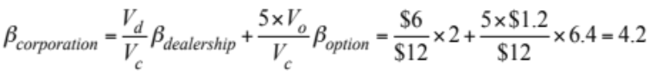
b. For expected cash flows of $300,000, the value of the operating dealership is $3 million. The value of a one-year call is:
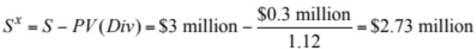
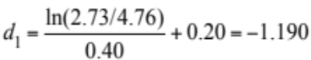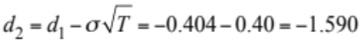
V_{c} = ($3 + 5 × $0.05) = $3.25 million.
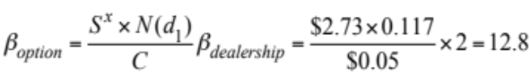
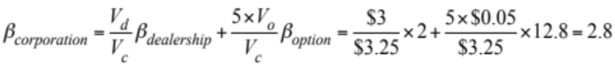
c. The options have a higher beta when cash flows are lower (in part b). The firm has a higher beta when cash flows are higher (in part a). With higher cash flows, the beta of the option is lower because the option is closer to in-the-money. This causes the value of the option to be higher and to affect the value and beta of the firm. With higher cash flows, the beta of the firm will be higher because a larger portion of its value comes from the value of the options. Intuitively, a firm with higher future expected cash flows in this setting has larger growth options.
22-10. The management of Southern Express Corporation is considering investing 10% of all future earnings in growth. The company has a single growth opportunity that it can take either now or in one period. Although the managers do not know the return on investment with certainty, they know it is equally likely to be either 10% or 14% per year. In one period, they will find out which state will occur. Currently the firm pays out all earnings as a dividend of $10 million; if it does not make the investment, dividends are expected to remain at this level forever. If Southern Express undertakes the investment, the new dividend will reflect the realized return on investment and will grow at the realized rate forever. Assuming the opportunity cost of capital is 10.1%, what is the value of the company just before the current dividend is paid (the cum-dividend value)?
Notice that if the firm makes the investment, the current dividend will be 10(1 – 0.1) = $9 million. It will have two possible growth rates in one period. If the return on investment turns out to be 14%, then the growth rate will be g = retention ratio × return on new investment = 0.1 × 0.14 = 1.4%. If the return on new investment is 10%, then the growth rate will be g = 0.1 × 0.1 = 1%. Assume the firm decides to wait to find out what the return on investment will be before making a decision. In this case, we need to decide whether to make the investment decision at time 1. If we make the investment and the return on investment is 10%, so the growth rate is 1% (the low growth state), the timeline will be as shown.

 |  | 1 |  | 2 |  | 3 |  | 4
Low Growth |  | 9 |  | 9 x 1.01¹ |  | 9 x 1.01² |  | 9 x 1.01³
No Growth |  | 10 |  | 10 |  | 10 |  | 10

From the timeline we can see that the value of the firm at time 1 (before the dividend is paid) if the firm decides to invest and grow is:
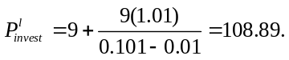
When the firm chooses not to invest, the value of the firm is:
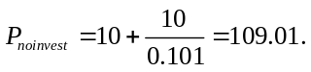
Clearly, the firm is better off not investing, so its value in this state is $109.01 million. (One way to see this immediately is to note that in this state the return on investment is less than the opportunity cost of capital.)
The return on investment is 14%, so the growth rate is 1.4% (the high growth state); the same logic shows that if the investment is undertaken, the value of the firm is:
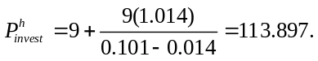
This value exceeds $109.01, the value if the investment is not undertaken, so the firm should undertake the investment. (Here the return on investment exceeds the opportunity cost of capital.)
What is the value of this firm today? To solve this problem, first write down the decision tree:

0 |  |  |  | 1
 |  | 50%
 |  | 50% |  | 113.89
 |  | 50%
10 |  | 50%
 |  |  |  | 109.01
Since each state is equally likely, the expected value of the firm in one period is 113.897 (0.5) + 109.01 (0.5). Computing the present value and adding today’s dividend (remember, we are computing the value before the dividend is paid) gives the firm value today of:
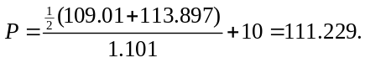
Consider what would have happened if instead of waiting one period to make the investment decision, Southern’s managers decided to make the decision today, i.e., at time 0 on the timeline. In this case, the decision tree looks like this:

0 |  |  |  | 1 |  | 2 |  | 3 |  | 4
 | High Growth |  |  | 9 x 1.014 |  | 9 x 1.014² |  | 9 x 1.014³ |  | 9 x 1.014⁴
 | Low Growth |  |  | 1 |  | 2 |  | 3 |  | 4
 |  |  |  | 9 x 1.01 |  | 9 x 1.01² |  | 9 x 1.01³ |  | 9 x 1.01⁴

We can derive the value of the firm using the same logic as above. The present value today (time 0) of the future dividends if the growth rate turns out to be high is:
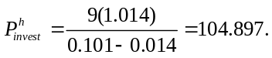
When the growth rate is low, the present value of future dividends at time 0 is:
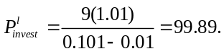
The value of the firm today is the present value of the expected future dividends plus the dividend today. Since both states are equally likely, we have:
Note that this value is higher than the value of the firm if management waits and makes the decision at time 1 when the return on investment becomes certain. So managers should give up the option to wait and invest today. Hence the value of the company is $111.39 million.
22-11. What decision should you make in Problem 2 if the one-year cost of capital is 15.44% and the profits last forever?
Decision Tree
First let’s calculate the NPV of investing in 3 possible states:
1. $100 Million State:
Timeline:

1 |  | 2 |  | 3
–500 |  | 100 |  | 100

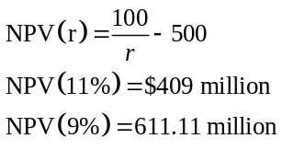
So the expected value if this state occurs is
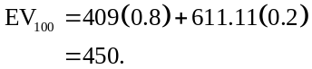
2. $50 Million State:
Timeline:

1 |  | 2 |  | 3
–500 |  | 50 |  | 50

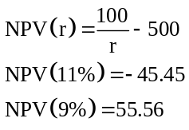

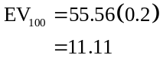
3. NPV is zero in the worst state, since profits are zero so the project will not be undertaken.
So the present value at time 0 of the expected value at time 1 is:
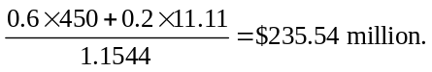
If the investment is made at time 0, then the NPV is the PV of the expected cash flows minus the initial investment. The expected cash flows are:
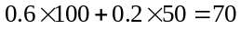 per year.
Timeline:
0 |  | 1 |  | 2 |  | 3
 |  | 70 |  | 70 |  | 70
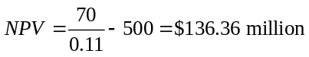
Alternatively, you can calculate the value of the project one year from now and discount that to get the same answer:
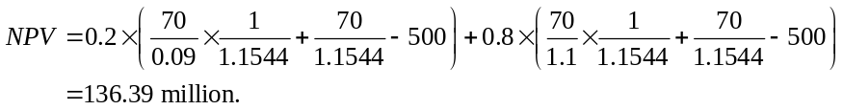
So you are better off waiting.
22-12. Your R&D division has just synthesized a material that will superconduct electricity at room temperature; you have given the go-ahead to try to produce this material commercially. It will take five years to find out whether the material is commercially viable, and you estimate that the probability of success is 25%. Development will cost $10 million per year, paid at the beginning of each year. If development is successful and you decide to produce the material, the factory will be built immediately. It will cost $1 billion to put in place, and will generate profits of $100 million at the end of every year in perpetuity. Assume that the current five-year risk-free interest rate is 10% per year, and the yield on a perpetual risk-free bond will be 12%, 10%, 8%, or 5% in five years. Assume that the risk-neutral probability of each possible rate is the same. What is the value today of this project?
Decision Tree

0 |  | 1 |  | 2 |  |  |  |  | 4 |  |  | 5 |  | 6 |  | 7
 |  |  |  |  |  |  |  |  | Successful
 |  |  |  |  |  |  |  |  |  |  |  | -1,000 |  | 100 |  | 100
 |  |  |  |  |  |  |  |  |  |  | 25%
 |  |  |  |  |  |  |  |  |  |  | 75%
-10 |  | -10 |  | -10 |  |  |  |  | -10
 |  |  |  |  |  |  |  |  | Unsuccessful
 |  |  |  |  |  |  |  |  |  |  |  | 0 |  | 0 |  | 0

If development is successful, then the NPV (at time 5) of producing the wire is:
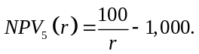
This is negative for r > 10%, so the wire will only be produced if the rates are 8% or 5%:
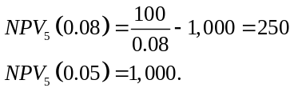
So the expected value of the growth opportunity at time 5 if development is successful is:
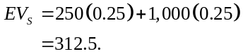
There is a 25% chance of success so the expected value at time 5 of the investment opportunity is:
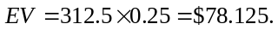
The NPV of the development opportunity at time 0 is therefore
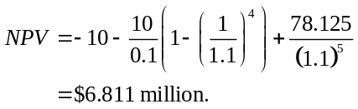
22-13. You are an analyst working for Goldman Sachs, and you are trying to value the growth potential of a large, established company, Big Industries. Big Industries has a thriving R&D division that has consistently turned out successful products. You estimate that, on average, the R&D division generates two new product proposals every three years, so that there is a 66% chance that a project will be proposed every year. Typically, the investment opportunities the R&D division produces require an initial investment of $10 million and yield profits of $1 million per year that grow at one of three possible growth rates in perpetuity: 3%, 0%, and −3%. All three growth rates are equally likely for any given project. These opportunities are always “take it or leave it” opportunities: If they are not undertaken immediately, they disappear forever. Assume that the cost of capital will always remain at 12% per year. What is the present value of all future growth opportunities Big Industries will produce?
Take a project that arrives in year n. The timeline is as follows.

N |  | n + 1 |  | n + 2 |  | n + 3
–10 |  | 1 |  | (1 + g) |  | (1 + g)²

The NPV of this investment opportunity is:
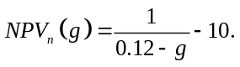
Now:
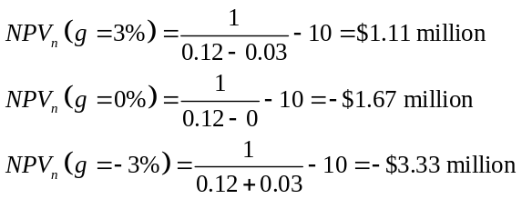
Therefore, only the projects with positive growth rates will be taken on. Thus, the expected value of any given investment opportunity is
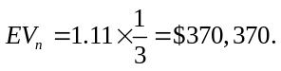
The probability that a project will arrive in any given year is 2/3, and so the expected value of the growth opportunity that will arrive in year n is:
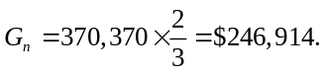
Putting this on a timeline:

0 |  | 1 |  | 2 |  | 3
 |  | 246,914 |  | 246,914 |  | 246,914

So the PV of all these opportunities today is:
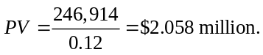
22-14. Repeat Problem 13, but this time assume that all the probabilities are risk-neutral probabilities, which means the cost of capital is always the risk-free rate and risk-free rates are as follows: The current interest rate for a risk-free perpetuity is 8%; in one year, there is a 64.375% chance that all risk-free interest rates will be 10% and stay there forever, and a 35.625% chance that they will be 6% and stay there forever. The current one-year risk-free rate is 7%.
Take a project that arrives in year n. The timeline is as follows.

N |  | n + 1 |  | n + 2 |  | n + 3
–10 |  | 1 |  | (1 + g) |  | (1 + g)²

The NPV of this investment opportunity is:
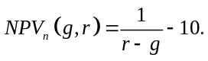
If the risk free rate is 10%:
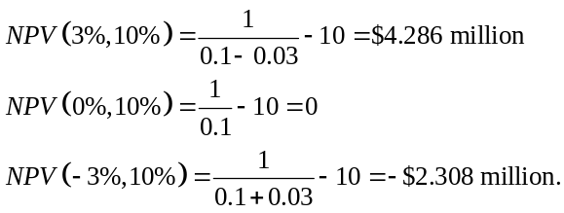
Therefore, only the projects with positive rates will be taken on. Thus, the expected value of any given investment opportunity is:
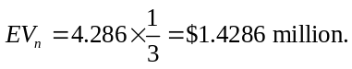
The probability that a project will arrive in any given year is 2/3, so the expected value of the growth opportunity that will arrive in year n is:
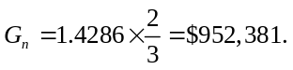
Putting this on a timeline:

0 |  | 1 |  | 2 |  | 3
 |  | 952,381 |  | 952,381 |  | 952,381

So the PV at time 1 of all these opportunities is:
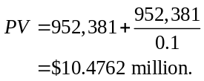
Now, if the risk free rate is 6%:
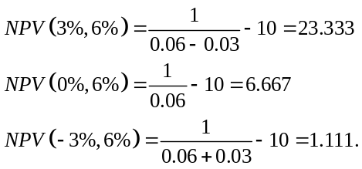
Therefore, regardless of the growth rate, all projects will be taken on. Thus, the expected value of any given investment opportunity is:
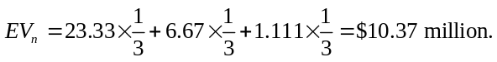
The probability that a project will arrive in any given year is 2/3, and so the expected value of the growth opportunity that will arrive in year n is
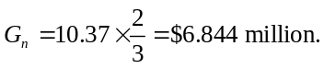
Putting this on a timeline:

0 |  | 1 |  | 2 |  | 3
 |  | 6.844 m |  | 6.844 m |  | 6.844 m

So the PV at time 1 of all these opportunities is:
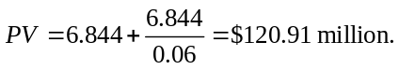
There is a 64.375% chance of rates going to 10% and a 35.625% chance of rates going to 6%. Putting this on a decision tree
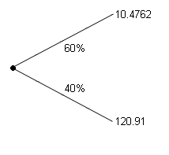
So the expected value is:
Computing the PV gives the answer:
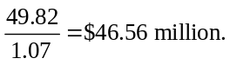
22-15. You own a small networking startup. You have just received an offer to buy your firm from a large, publicly traded firm, JCH Systems. Under the terms of the offer, you will receive 1 million shares of JCH. JCH stock currently trades for $25 per share. You can sell the shares of JCH that you will receive in the market at any time. But as part of the offer, JCH also agrees that at the end of the next year, it will buy the shares back from you for $25 per share if you desire. Suppose the current one-year risk-free rate is 6.18%, the volatility of JCH stock is 30%, and JCH does not pay dividends.
a. Is this offer worth more than $25 million? Explain.
b. What is the value of the offer?
a. The offer is worth more than $25 million because of the put option.
b. The value of the offer is the current value of the shares plus the value of the put option.
To calculate the value of the put:
S = 25
PV(K) = 25 / (1.0618)
T = 1
= 0.30
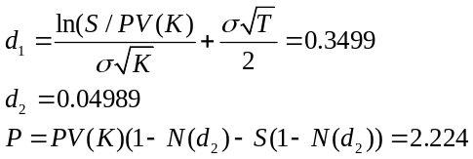
So, the value of the offer is 25 + 2.224 = $27.224 million.
(Note that the actual value will be slightly higher because this uses the value of a European put.)
22-16. You own a wholesale plumbing supply store. The store currently generates revenues of $1 million per year. Next year, revenues will either decrease by 10% or increase by 5%, with equal probability, and then stay at that level as long as you operate the store. You own the store outright. Other costs run $900,000 per year. There are no costs for shutting down; in that case, you can always sell the store for $500,000. What is the business worth today if the cost of capital is fixed at 10%?
Decision Tree
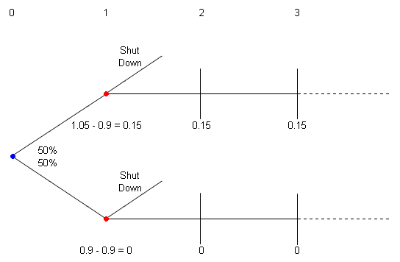
The value of the store is the maximum of the PV of all future profits and $500,000, the value of selling the store.
If the revenues decrease, then future profits are zero so the store should be shut down. Hence the value in this state is $500,000.
If the revenues increase, then the PV of future profits at time 1 are:
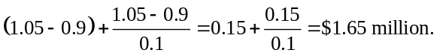
So it is optimal to keep the store running. Putting this on a decision tree:
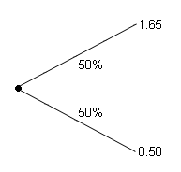
So the PV of the time 1 expected value is:
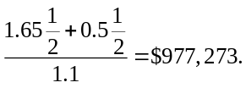
Since this is greater than $500,000, the value of the store is $977,273 with the option to abandon.
22-17. You own a copper mine. The price of copper is currently $1.50 per pound. The mine produces 1 million pounds of copper per year and costs $2 million per year to operate. It has enough copper to operate for 100 years. Shutting the mine down would entail bringing the land up to EPA standards and is expected to cost $5 million. Reopening the mine once it is shut down would be an impossibility given current environmental standards. The price of copper has an equal (and independent) probability of going up or down by 25% each year for the next two years and then will stay at that level forever. Calculate the NPV of continuing to operate the mine if the cost of capital is fixed at 15%. Is it optimal to abandon the mine or keep it operating?
Decision Tree:

Copper Price:
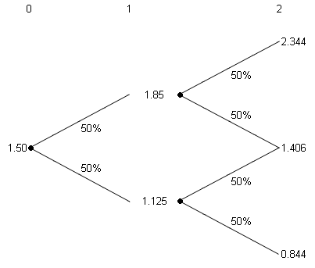
Cash Flows
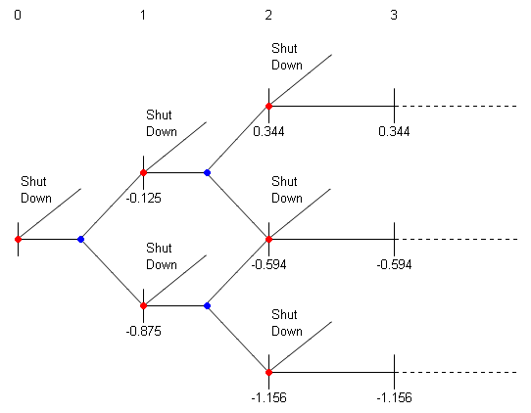
First, determine whether the mine is operating or shut down in each possible state at time 2.
When the copper price is $2.344, the mine’s profits are $0.344 million/year for 98 years and then it will cost $5 million to shut the mine down. The PV at time 2 of these cash flows is:
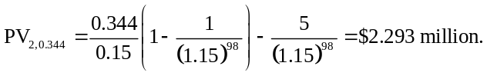
Since it will cost $5 million to shut the mine down, it is better to leave it operating.
Similarly, when the copper price is $1.406,
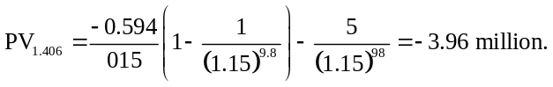
Again, since the value is greater than –$5 million, it is better to operate the mine.
Finally, when the copper price is $0.844:
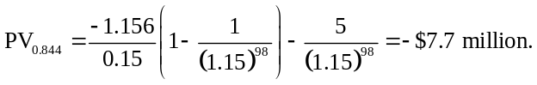
Since it is smaller than –$5 million, the mine should be shut down.
Next, calculate the value of the mine if it is operating at time 1 when the copper price is $1.85. Putting the value of the mine plus the cash flow at time 2 on a decision tree:
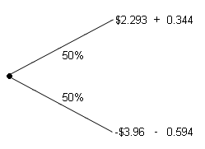
The present value at time 1 of the expected value at time 2 is
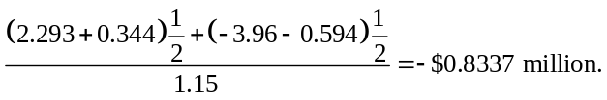
So it is optimal to run the mine in this state.
Next, calculate the value of the mine if it is operating at time 1 when the copper price is $1.125. Putting the value of the mine plus the cash flow at time 2 on a decision tree:
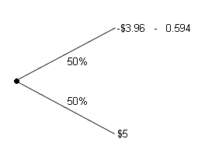
The present value at time 1 of the expected value at time 2 is
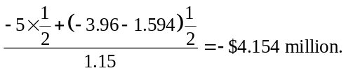
So it is optimal to run the mine in this state.
Finally, we calculate the value of the mine at time 0 if it is operating.
Putting the value of the mine plus the cash flow at time 1 on a decision tree:
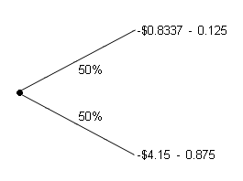
The present value at time 0 of the expected value at time 1 is:
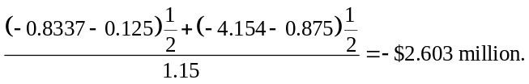
So the mine is worth –$2.603 million. Even though it is worth a negative amount because in most states it will lose money for the next 98 years, it is not optimal to shut down the mine at time 0 because the costs of shutting down are even greater.
22-18. An original silver dollar from the late eighteenth century consists of approximately 24 grams of silver. At a price of $0.19 per gram ($6 per troy ounce), the silver content of the coin is currently worth about $4.50. Assume that these coins are in plentiful supply and are not collector’s items, so they have no numismatic value. If the current price of silver is $0.19 per gram, will the price of the coin be greater than, less than, or equal to $4.50? Justify your answer.
The silver dollar is actually a real option because you always have the option to use it as a dollar coin. Although at the current price of silver this does not make sense, if the price of silver dropped below 4.1¢/gram ($1.28/troy ounce) the value of the silver in the coin would drop below $1. The coin can always be used a dollar coin, so its price cannot fall below a dollar (by the Law of One Price). Since the price of 24 grams of silver can drop below $1, the coin must be worth more than 24 grams of silver or $4.50. So the coin must be worth $4.50.
22-19. What implicit assumption is made when managers use the equivalent annual benefit method to decide between two projects with different lives that use the same resource?
The equivalent annual cost method implicitly assumes that, at the end of the life of the shorter length project, you can replace the shorter length project on the original terms.
22-20. You own a cab company and are evaluating two options to replace your fleet. Either you can take out a five-year lease on the replacement cabs for $500 per month per cab, or you can purchase the cabs outright for $30,000, in which case the cabs will last eight years. You must return the cabs to the leasing company at the end of the lease. The leasing company is responsible for all maintenance costs, but if you purchase the cabs, you will buy a maintenance contract that will cost $100 per month for the life of each cab. Each cab will generate revenues of $1000 per month. Assume the cost of capital is fixed at 12%.
a. Calculate the NPV per cab of both possibilities: purchasing the cabs or leasing them.
b. Calculate the equivalent monthly annual benefit of both opportunities.
c. If you are leasing a cab, you have the opportunity to buy the used cab after five years. Assume that in five years a five-year-old cab will cost either $10,000 or $16,000 with equal likelihood, will have maintenance costs of $500 per month, and will last three more years. Which option should you take?
a. Timeline:

 |  | 0 |  | 1 |  | 2 |  |  |  |  | 60 |  | 61 |  |  |  |  | 96
Lease |  |  |  | 500 |  | 500 |  |  |  |  | 500
Buy |  | –30,000 |  | 900 |  | 900 |  |  |  |  | 900 |  | 900 |  |  |  |  | 900

Converting the cost of capital to a monthly discount rate gives:
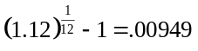, so the monthly discount rate is 0.949%.
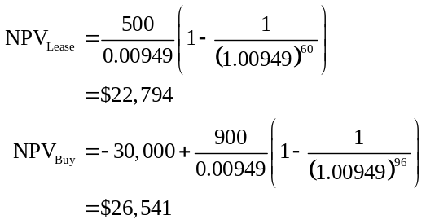
b. Timeline:

 |  | 0 |  | 1 |  | 2 |  |  |  |  | 60 |  | 61 |  |  |  |  | 96
Lease |  | –$22,794 |  | X |  | X |  |  |  |  | X
Buy |  | –$26,541 |  | Y |  | Y |  |  |  |  | Y |  | Y |  |  |  |  | Y

Solving for the EAB of leasing:
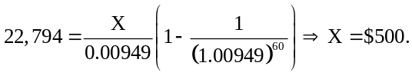
Solving for the EAB of buying:
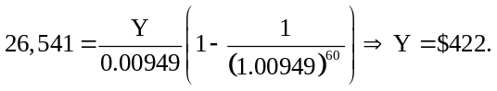
c. Decision Tree
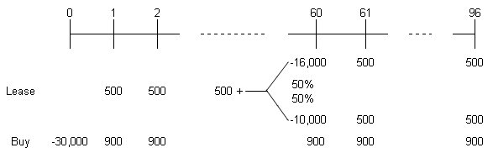
In month 60, the NPV of buying a cab is either
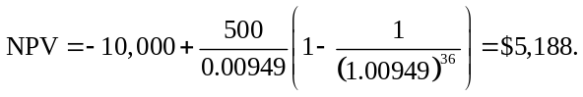
Or
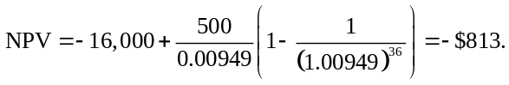
The expected value of replacing the cabs in year 5 is:
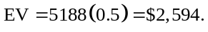
The value today of this:
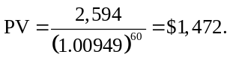
Adding this to the NPV of leasing from part a gives:
Since the NPV of buying as not changed
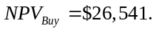
So you should buy the cab.
22-21. You own a piece of raw land in an up-and-coming area in Gotham City. The costs to construct a building increase disproportionately with the size of the building. A building of q square feet costs 0.1 × q² to build. After you construct a building on the lot, it will last forever but you are committed to it: You cannot put another building on the lot. Buildings currently rent at $100 per square foot per month. Rents in this area are expected to increase in five years. There is a 50% chance that they will rise to $200 per square foot per month and stay there forever, and a 50% chance that they will stay at $100 per square foot per month forever. The cost of capital is fixed at 12% per year.
a. Should you construct a building on the lot right away? If so, how large should the building be?
b. If you choose to delay the decision, how large a building will you construct in each possible state in five years?
a. Converting the cost of capital to a monthly discount rate gives:
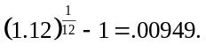
So 12% per year is equivalent to 0.949% per month. If rents rise then a building of size q will be worth:
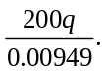
This building will cost 0.1q² to build, so the NPV is:
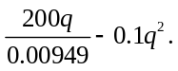
To find the maximum value of this function, take the derivative and set the results equal to zero:
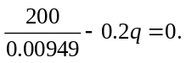
Solving for q gives:
q = 105,387 sq. ft.
Doing the same thing in the state with $100/sq. ft. rents gives:
q = 52,694.
b. If you wait then the NPV of building in 200 sq. ft. state is
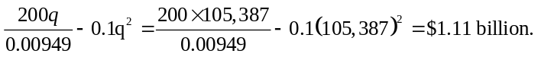
Repeating for the $100 sq ft state gives $278 million.
So the PV of this today is:
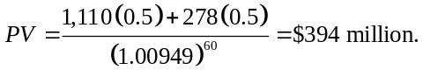
If we build today the expected cash flows are:
0 |  | 1 |  | 2 |  |  |  |  | 60 |  | 61 |  | 62
 |  | 100q |  | 100q |  |  |  |  | 100q |  | 150q |  | 150q

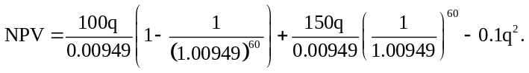
Taking the derivative, setting the result equal to zero and solving for q gives the optimal size to the building today:
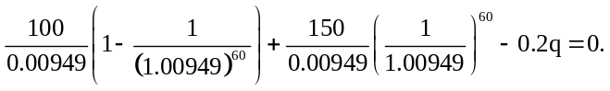
q = 67,644 sq. ft.
So the NPV is:
NPV = $458 million.
So we should build a building of 67,644 sq. ft. today.
22-22. Genenco is developing a new drug that will slow the aging process. In order to succeed, two breakthroughs are needed, one to increase the potency of the drug, and the second to eliminate toxic side effects. Research to improve the drug’s potency is expected to require an upfront investment of $10 million and take 2 years; the drug has a 5% chance of success. Reducing the drug’s toxicity will require a $30 million up-front investment, take 4 years, and has a 20% chance of success. If both efforts are successful, Genenco can sell the patent for the drug to a major drug company for $2 billion. All risk is idiosyncratic, and the risk-free rate is 6%.
a. What is the NPV of launching both research efforts simultaneously?
b. What is the optimal order to stage the investments?
c. What is the NPV with the optimal staging?
a. –10 – 30 + 0.05 × 20 × 2000/1.06⁴ = –24 million
b. Potency : (1 – 0.05/1.06²)/10 = 0.096
Toxicity: (1 – 0.20/1.06⁴)/30 = 0.028
So, work on potency, then toxicity—higher risk and smaller investment.
c. If potency works, then the NPV of continuing is
(–30 + 0.2 2000/1.06⁴)
So the NPV of starting is
–10 + 0.05 (NPV of starting toxicity)/1.06²
= –10 + 0.05 (–30 + 0.2 2000/1.06⁴)/1.06² = $2.76 million.
22-23. Your engineers are developing a new product to launch next year that will require both software and hardware innovations. The software team requests a budget of $5 million and forecasts an 80% chance of success. The hardware team requests a $10 million budget and forecasts a 50% chance of success. Both teams will need 6 months to work on the product, and the risk-free interest rate is 4% APR with semiannual compounding.
a. Which team should work on the project first?
b. Suppose that before anyone has worked on the project, the hardware team comes back and revises their proposal, changing the estimated chance of success to 75% based on new information. Will this affect your decision in (a)?
a. Software: (1 – 0.80/1.02)/5 = 0.043
Hardware: (1 – 0.50/1.02)/10 = 0.051
>> Hardware should go first
b. Hardware: (1 – 0.75/1.02)/10 = 0.026
>> Yes, software should go first now.
22-24. Your firm is thinking of expanding. If you invest today, the expansion will generate $10 million in FCF at the end of the year, and will have a continuation value of either $150 million (if the economy improves) or $50 million (if the economy does not improve). If you wait until next year to invest, you will lose the opportunity to make $10 million in FCF, but you will know the continuation value of the investment in the following year (that is, in a year from now, you will know what the investment continuation value will be in the following year). Suppose the risk-free rate is 5%, and the risk-neutral probability that the economy improves is 45%. Assume the cost of expanding is the same this year or next year.
a. If the cost of expanding is $80 million, should you do so today, or wait until next year to decide?
b. At what cost of expanding would there be no difference between expanding now and waiting? To what profitability index does this correspond?
a. V0 = ( 0.45 × (150) + 0.55 × (50)+10)/1.05 = 100
NPV(expand) = 100 – 80 = 20
NPV(wait) = 0.45 × (150 – 80)/1.05 = 30
So, optimal to wait.
b. NPV(expand) = 100 – C =
NPV(wait) = 0.45 × (150 – C)/1.05
So, C = 62.5
Prof Index = NPV/C = (100 – 62.5)/62.5 = 0.6
22-25. Assume that the project in Example 22.5 pays an annual cash flow of $100,000 (instead of $90,000).
a. What is the NPV of investing today?
b. What is the NPV of waiting and investing tomorrow?
c. Verify that the hurdle rate rule of thumb gives the correct time to invest in this case.
a. 100k/.054 – 1m = 851.852k
b. NPV(up) = 0, NPV(down) = 100k/0.05 – 1m = 1m
PV = 0.9 × 1m/1.08 = $833,333k
c. Hurdle rate rule: NPV = 100k/0.09 – 1m = 111.11k > 0, so invest now, correct.
22-26. Assume that the project in Example 22.5 pays an annual cash flow of $80,000 (instead of $90,000).
a. What is the NPV of investing today?
b. What is the NPV of waiting and investing tomorrow?
c. Verify that the hurdle rate rule of thumb gives the correct time to invest in this case.
a. 80k/0.054 – 1m = 481.48k
b. NPV(down) = 80k/0.05 – 1m = 600k
PV = 0.9 × 600/1.08 = 500k
c. 80/0.09 – 1m = –111k, so wait, correct

